**Detailed Procedure**

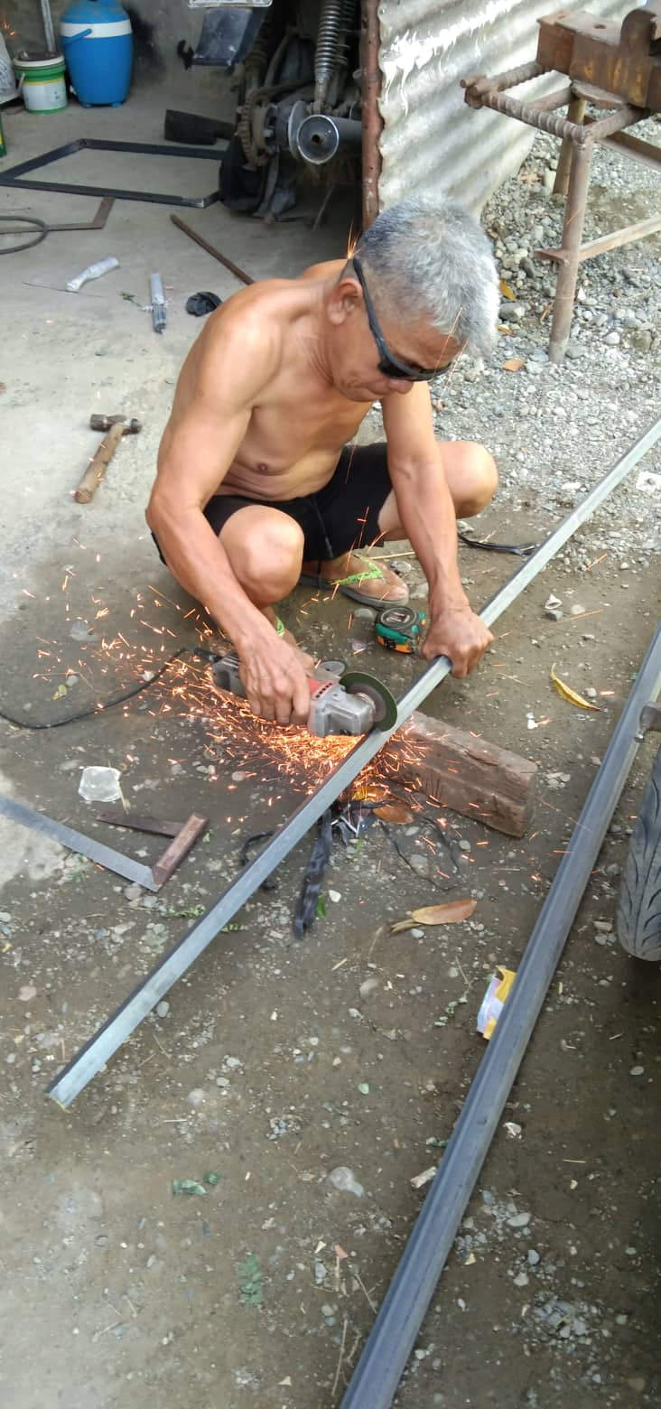

Angle bars with measurement each of 72, 84 and 54cm. are prepared using angle grinder. A welding machine is use to weld the pieces together into the shape of the frame.

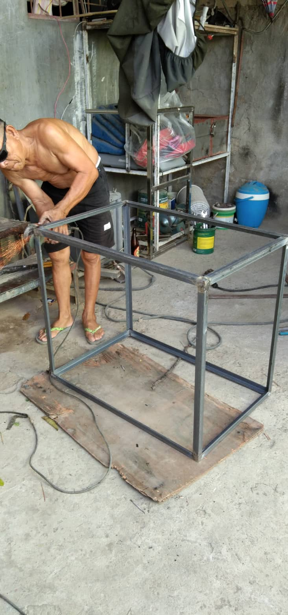

Having the rigid frame, the frame is turned upside down to weld the caster wheels on each corner of the frame as to give the frame maneuverability.

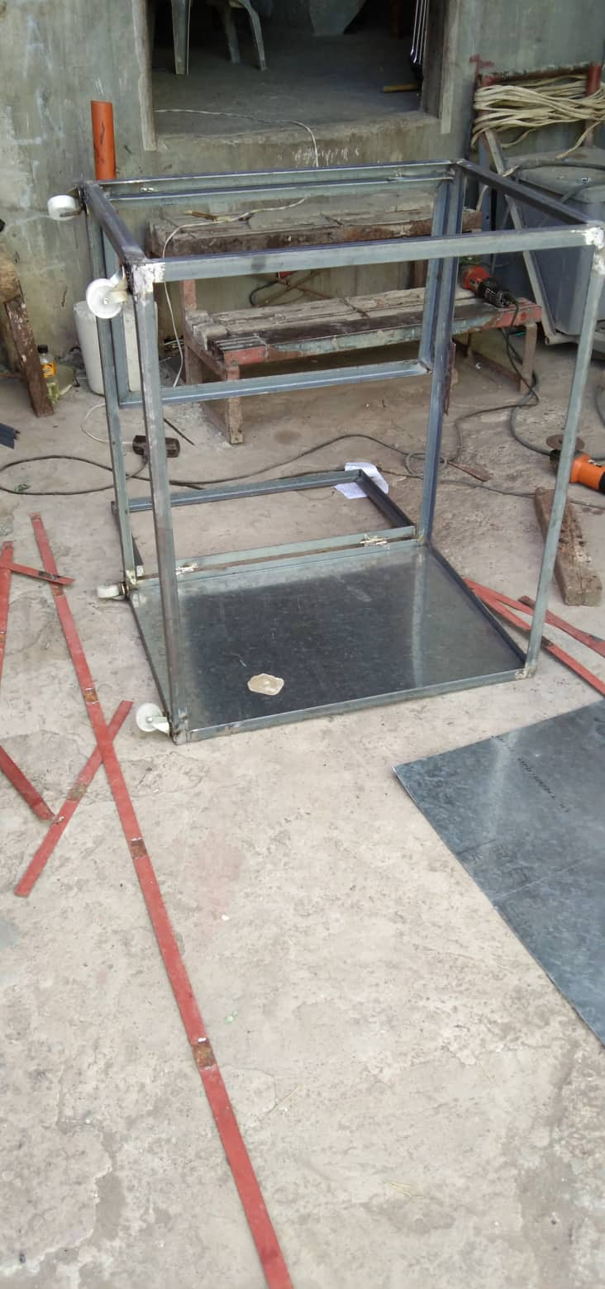

A 39 and 67cm angle bars are prepared using the angle grinder and welded into shape of a door frame.

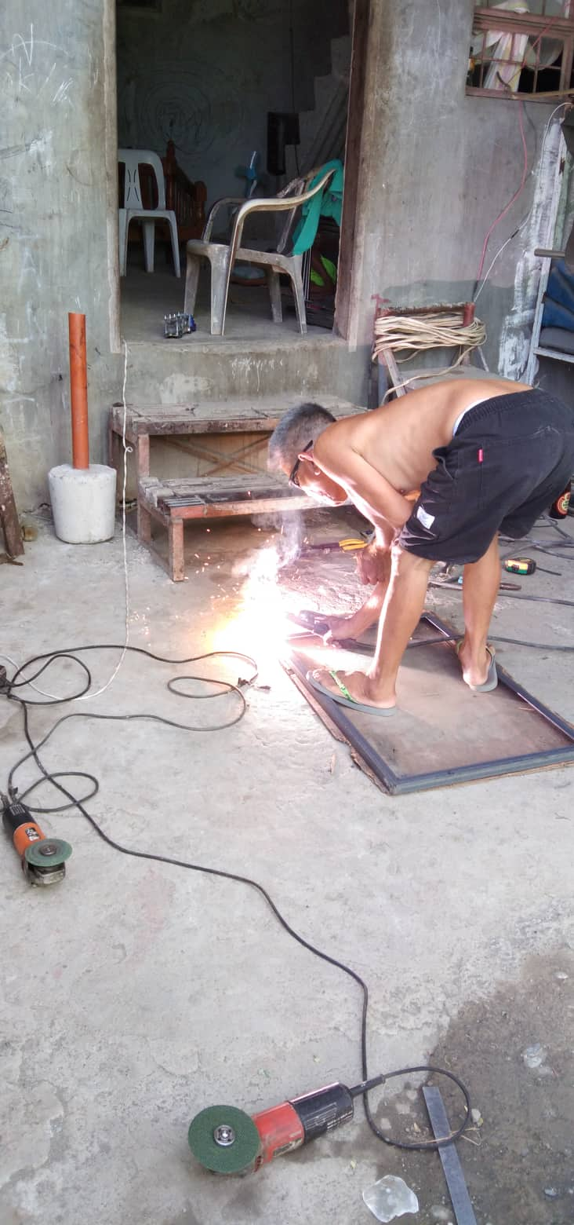

The door was fixed to the frame using cylindrical hinges. Roller catches are fixed onto the front top and bottom center of the frame.

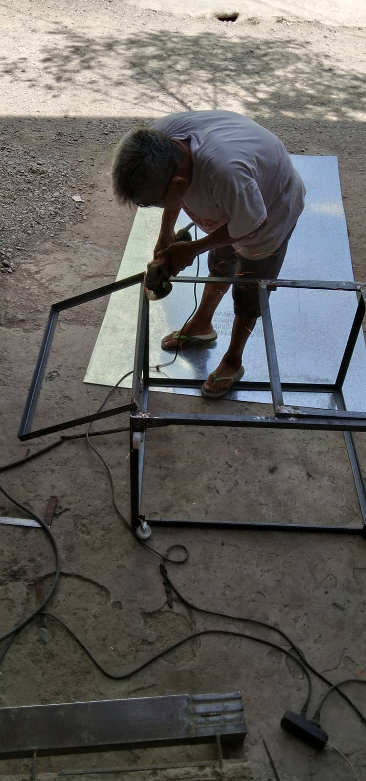

After turning the frame upright, galvanized steel walls are cut and prepared. Using the welding machine, the steel walls are fixed onto the frame reinforcing with flat bars.

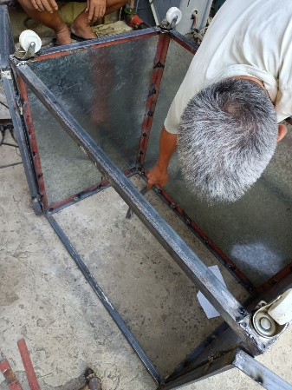

Using a measuring tape to have the center of the door frame, two holes were drilled. The aluminum handle bars are screwed onto the frame. Using the same technique, two holes were drilled on the side of the frame and aluminum handle bars are fixed using screws onto the frame.

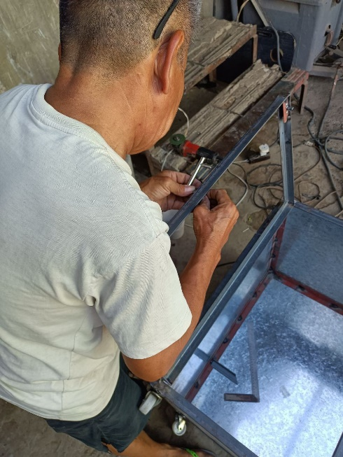

Using the angle grinder, the frame was sanded off of sharp edges. After smoothing the frame, using aerosol paint, a white coat was applied inside and outside the frame.

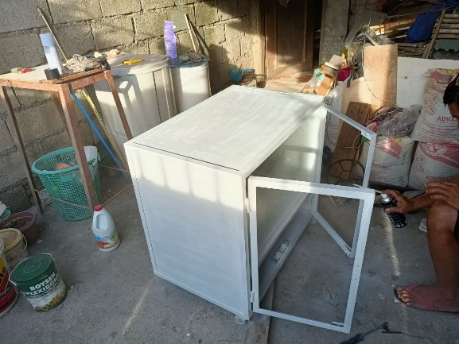

A clear coat was applied after drying of the primer. A two 49 and 81cm angle bar are prepared and welded into a shape of rectangle and galvanized wire mesh are cut accordingly to the dimension and welded onto the shape. The mesh, who serves as the object holder are coated with primer and clear coat also.

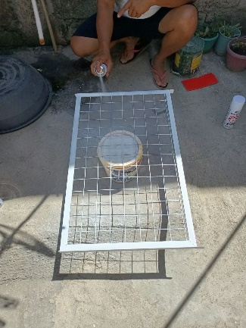

The wire mesh and the circuit chamber divider are fixed onto the inside of the frame using teks screw.

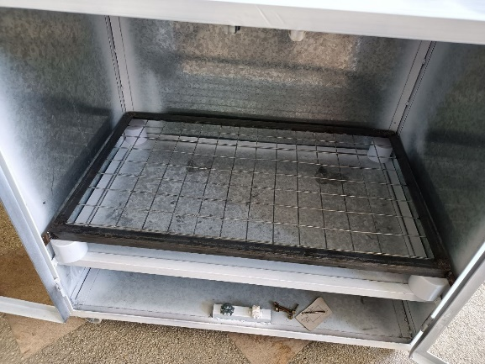

¼ inch thick clear glass are fixed onto the door frame using glass silicon putty.

